**Section 0:**

1.Create a directory ‘project_dir’ &cd to ‘project_dir’.

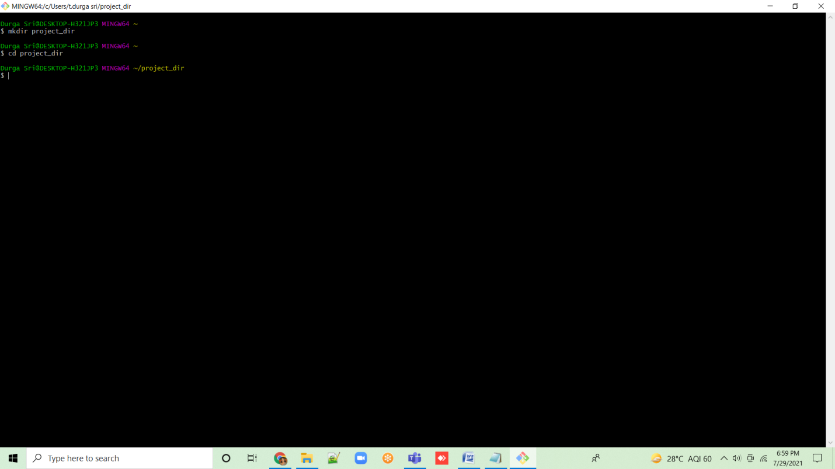

2. Initialize git version database. (git init)

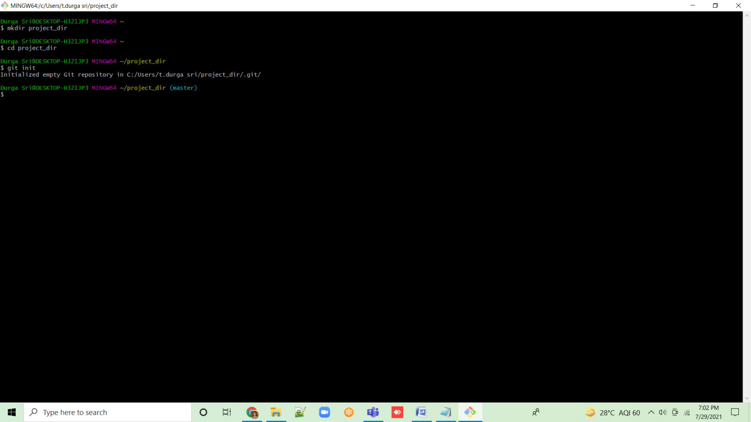

3.Create a new file index.html

4. Check the git status.You should find index.html as untracked file.

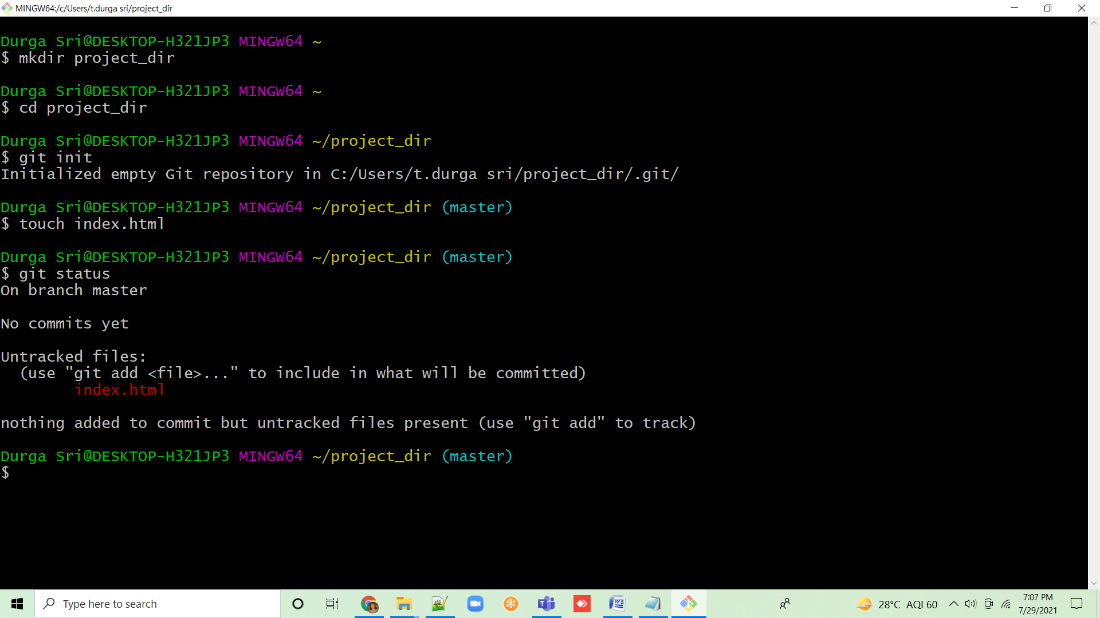

5. Stage the index.html file

6. Commit index.html

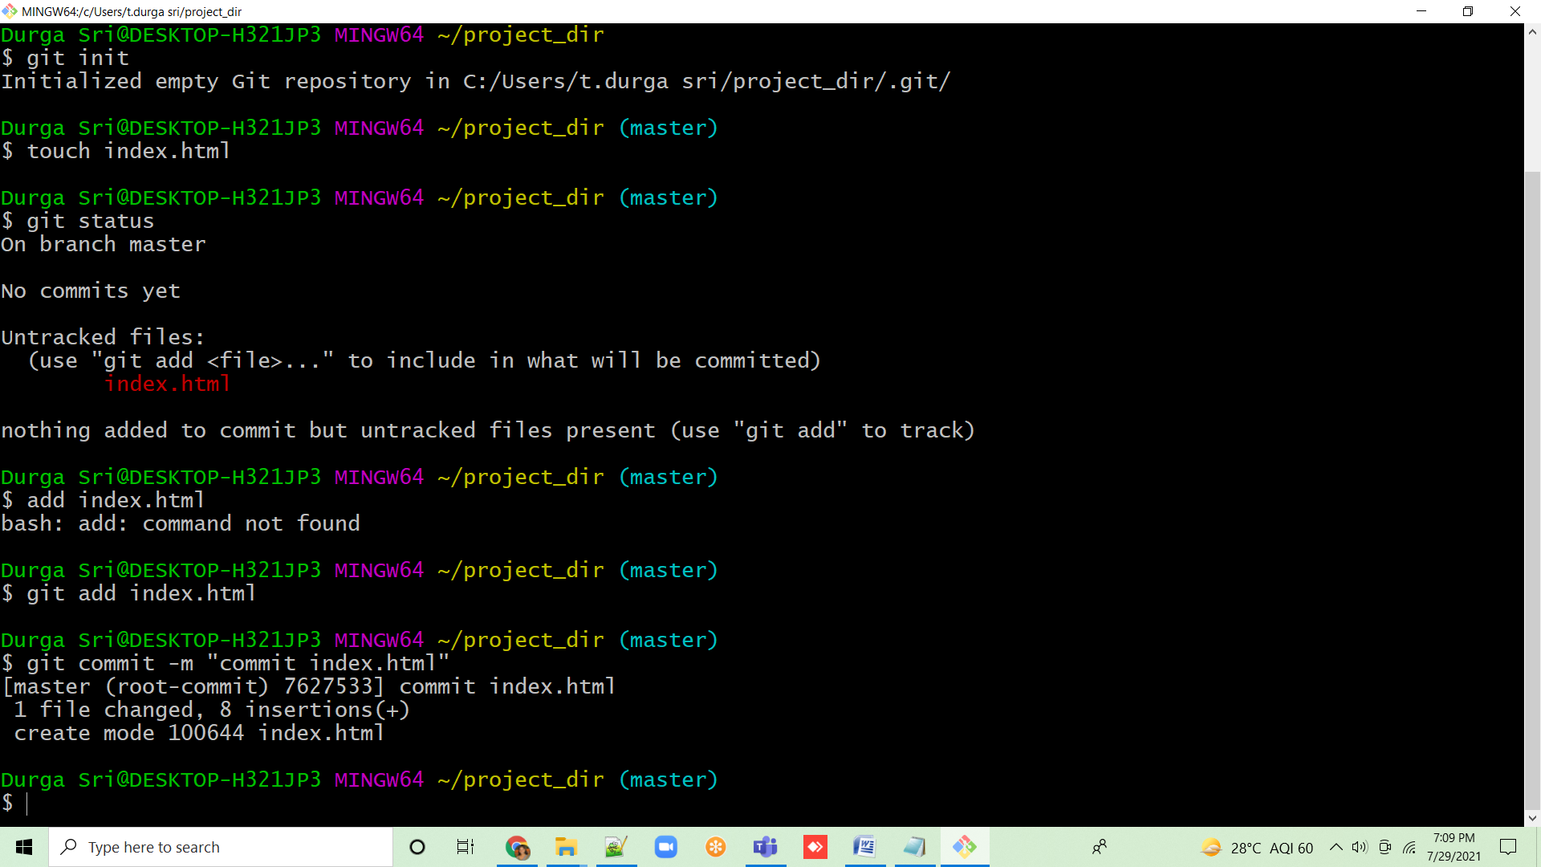

7. Make few changes in index.html & create a new file info.txt.

8.Check git status. You should find index.html & info.txt as untracked files.

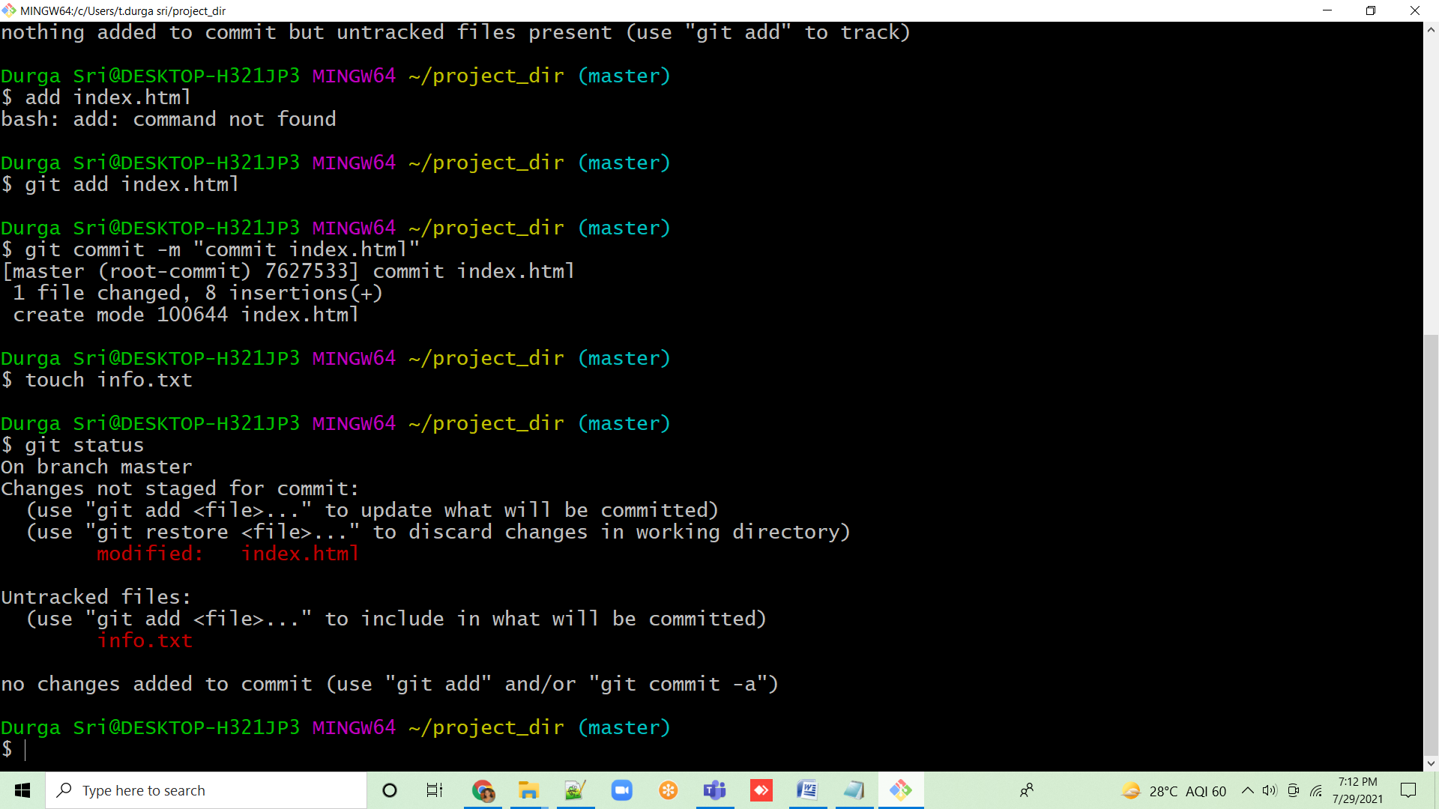

9. Configure GIT to ignore all txt files.

10. Again check the git status. You should find only index.html as untracked file.

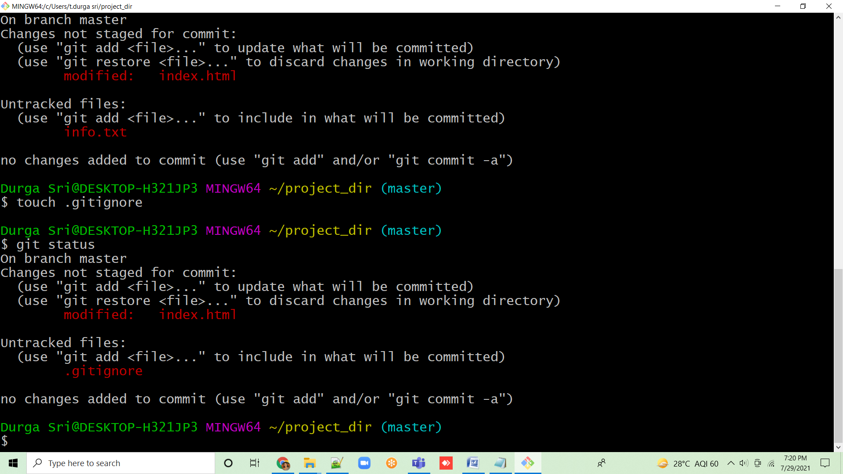

11. State & commit index.html.

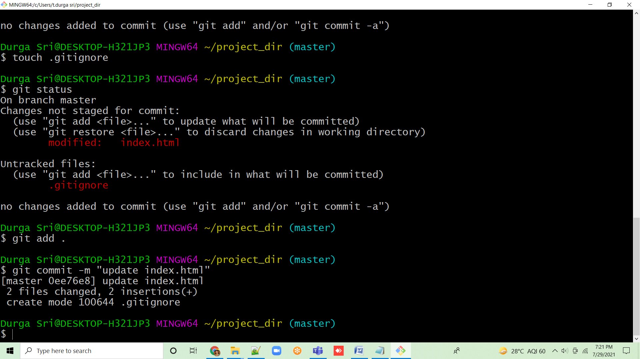

12. Log all your commits so far.

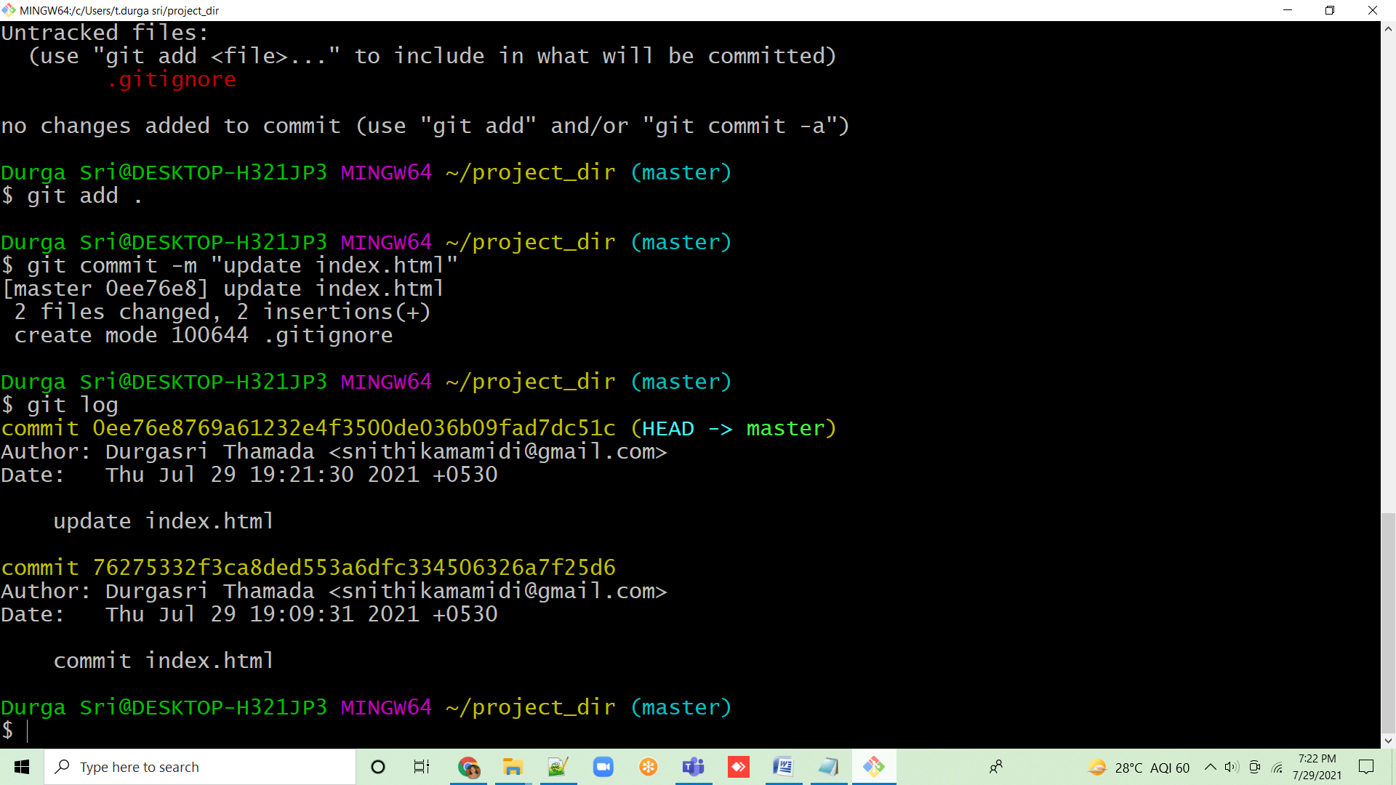

13. Make some changes in index.html

14. Revert the change made in the previous step using git command.

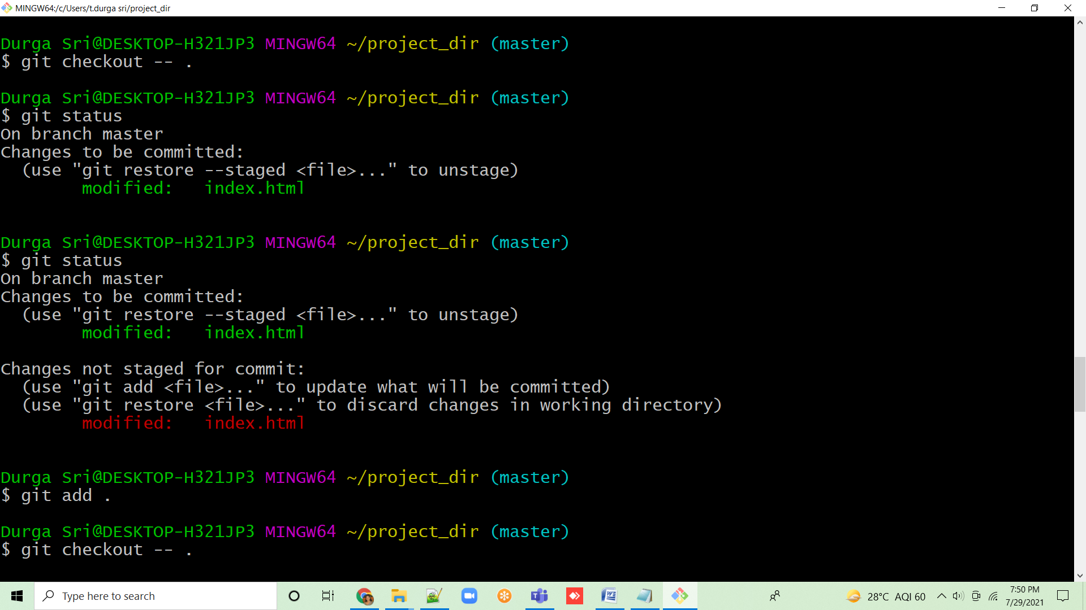

15. Again change index.html

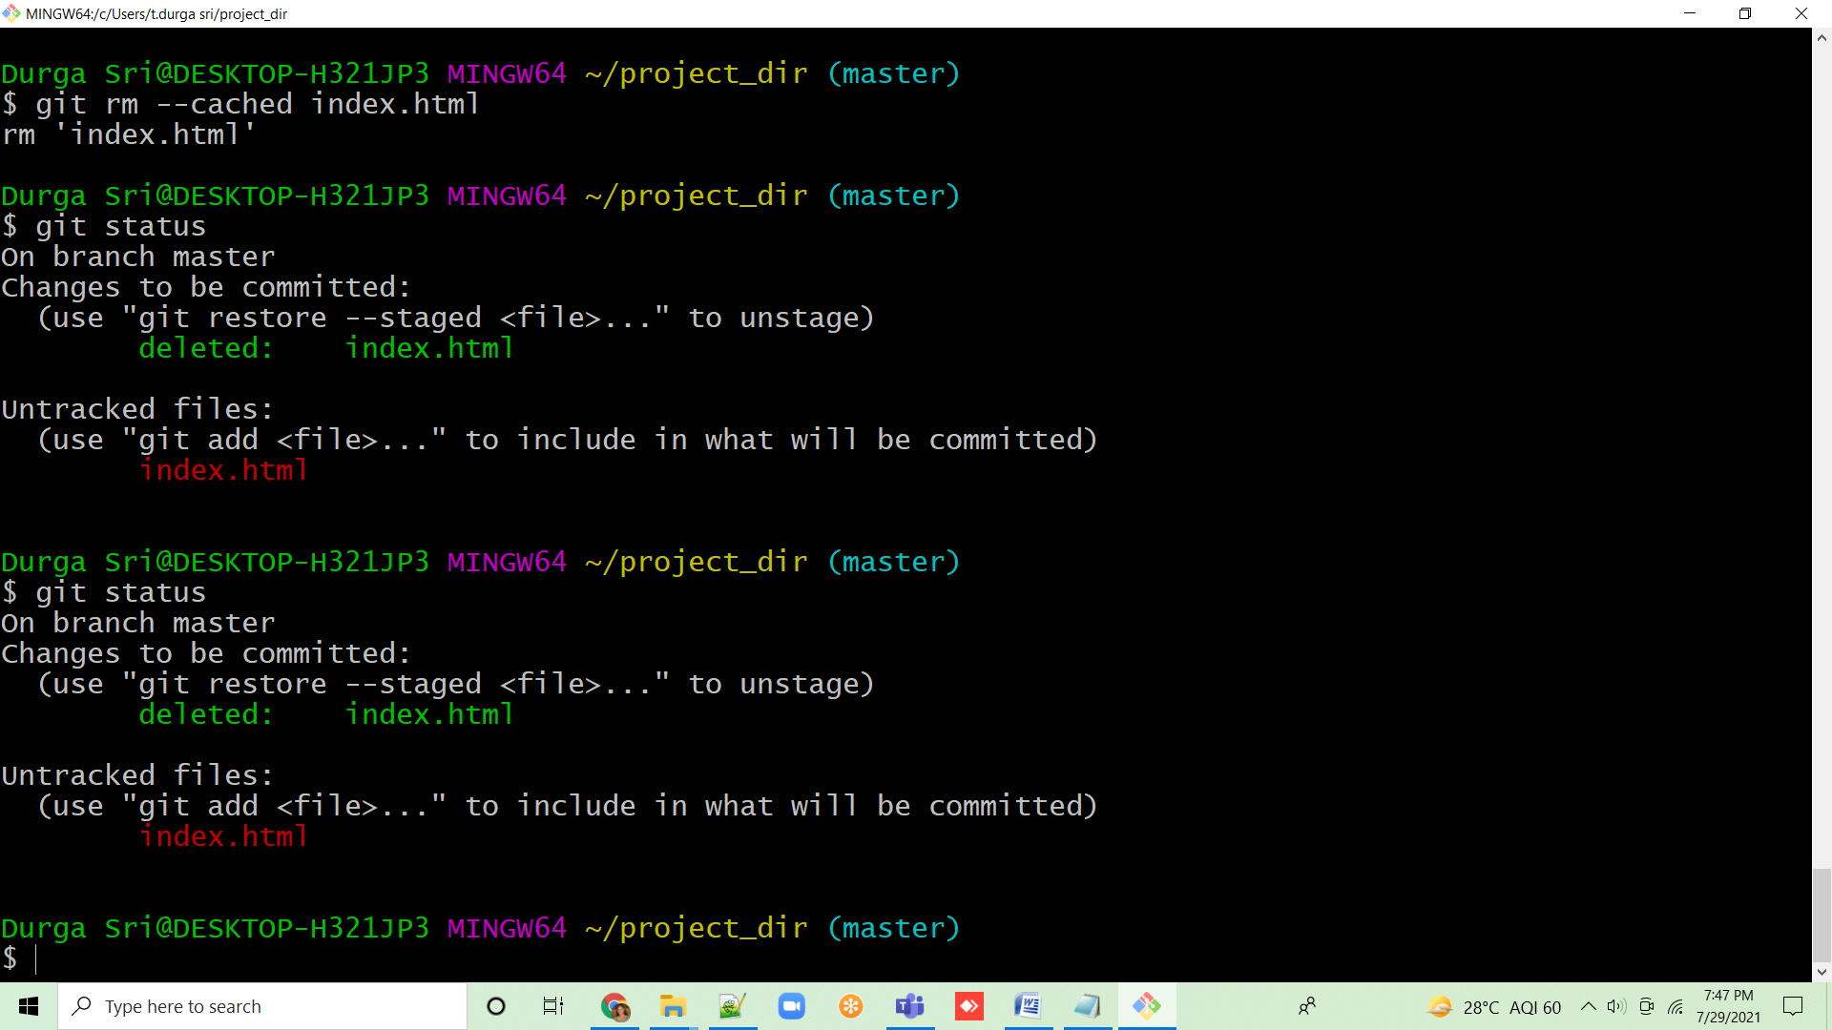

16. Stage index.html

17. Revert back the last stage

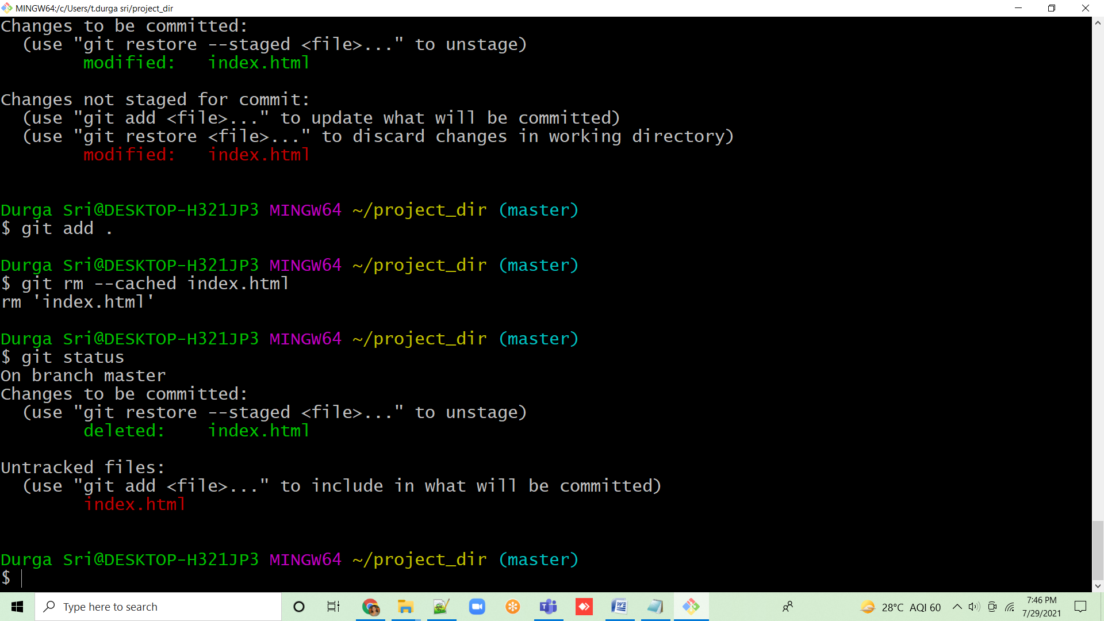

18. Rename ‘add’ command to ‘my-add’

19. Using my-add command Stage index.html again & commit the changes.

20. Revert the last commit.

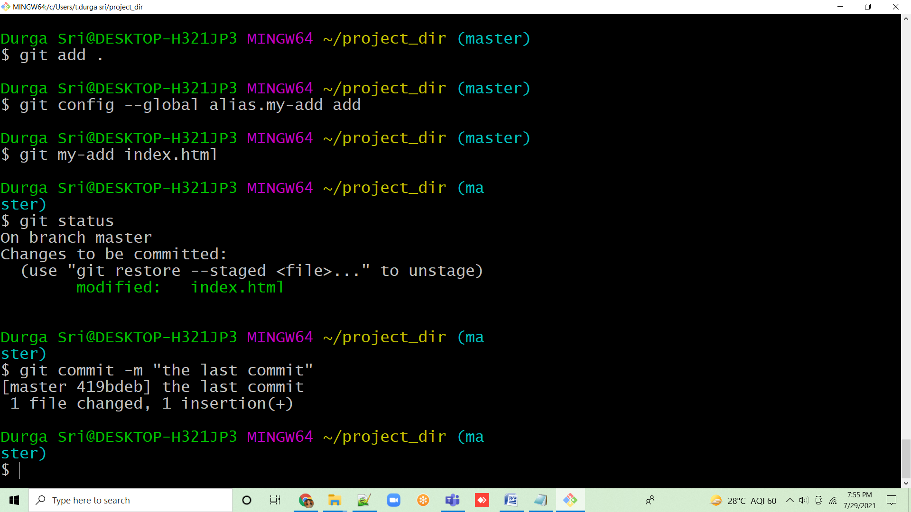

**Section 1:**

22. Create an empty directory ‘Assignments’ & cd to ‘Assignments’

23. Create a file README.txt inside ‘Assignments’ & write few lines about the contents of ‘Assignments’ folder

24. Commit README.txt file

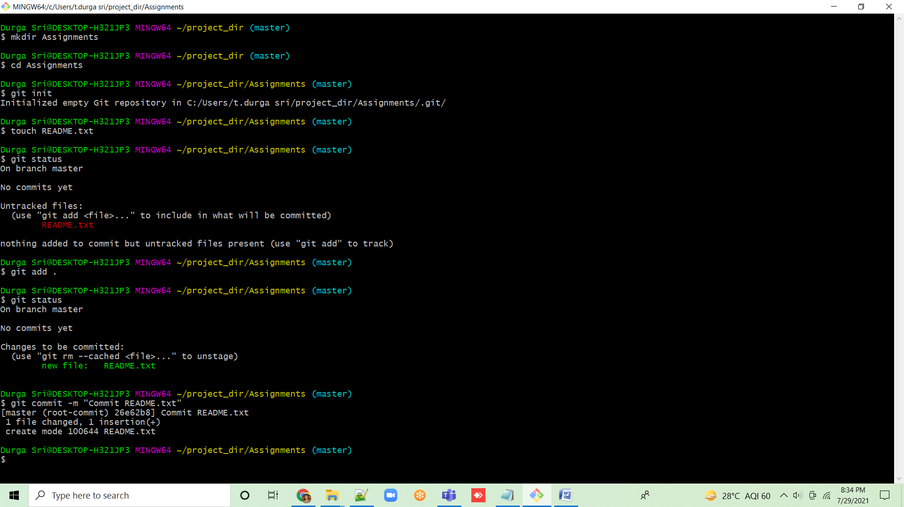

25. Now create a new branch ‘html-assignments’

26. Switch to ‘html-assignments’ branch.

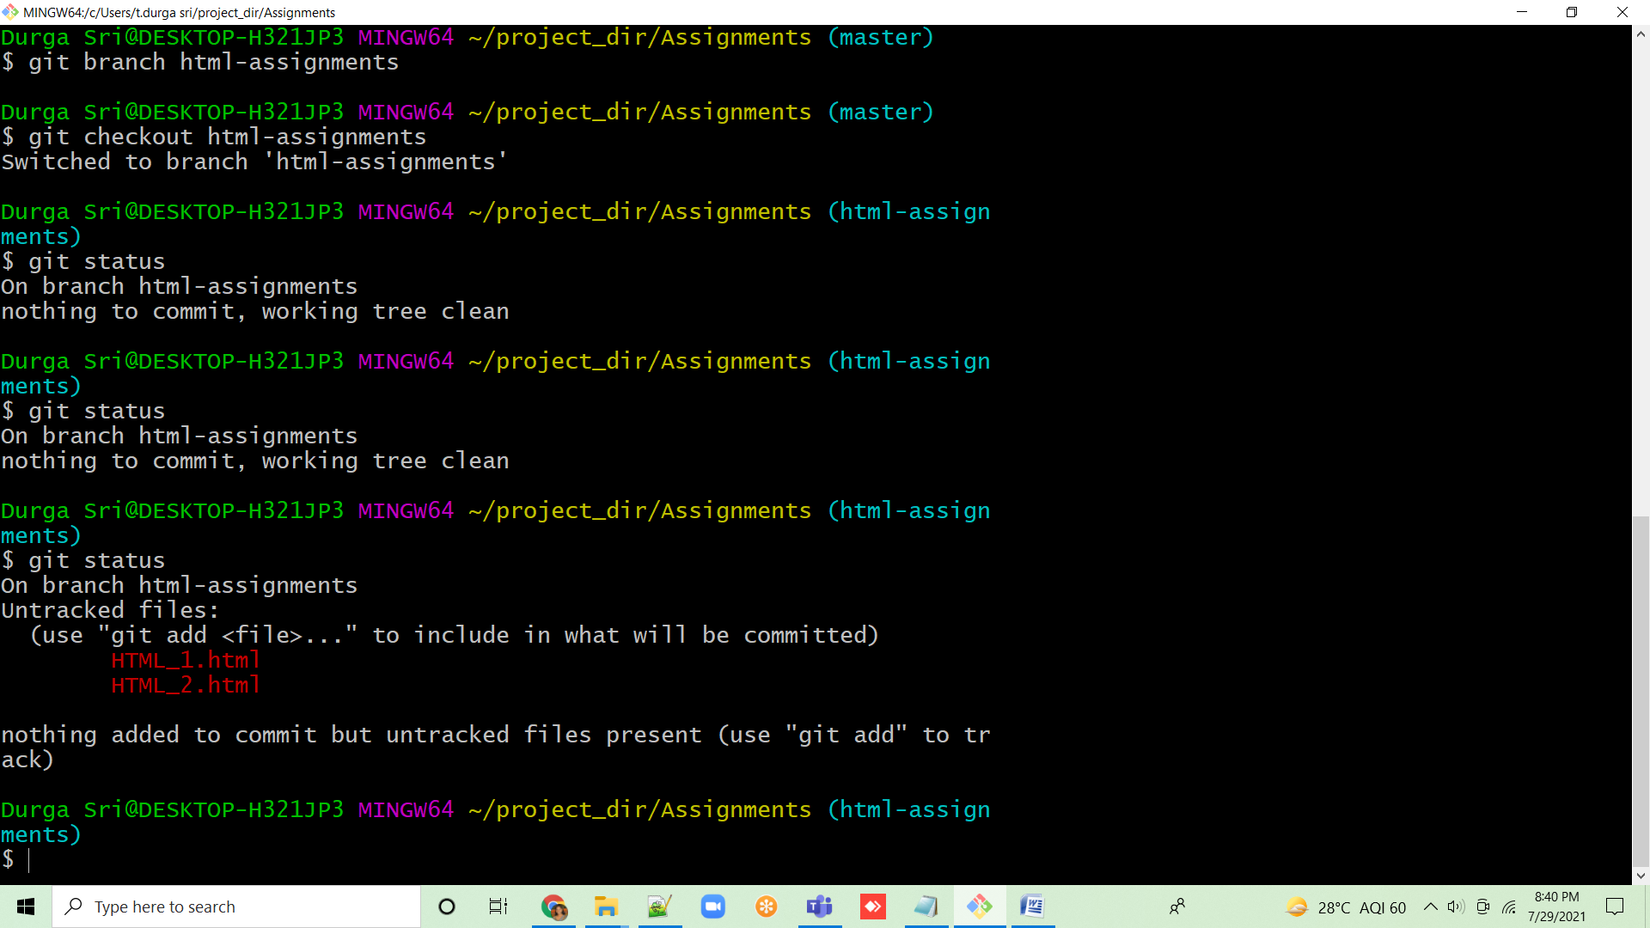

27. Copy all HTML assignments inside ‘Assignments’ folder.

28. Commit HTML assignments into ‘html-assignments’ branch.

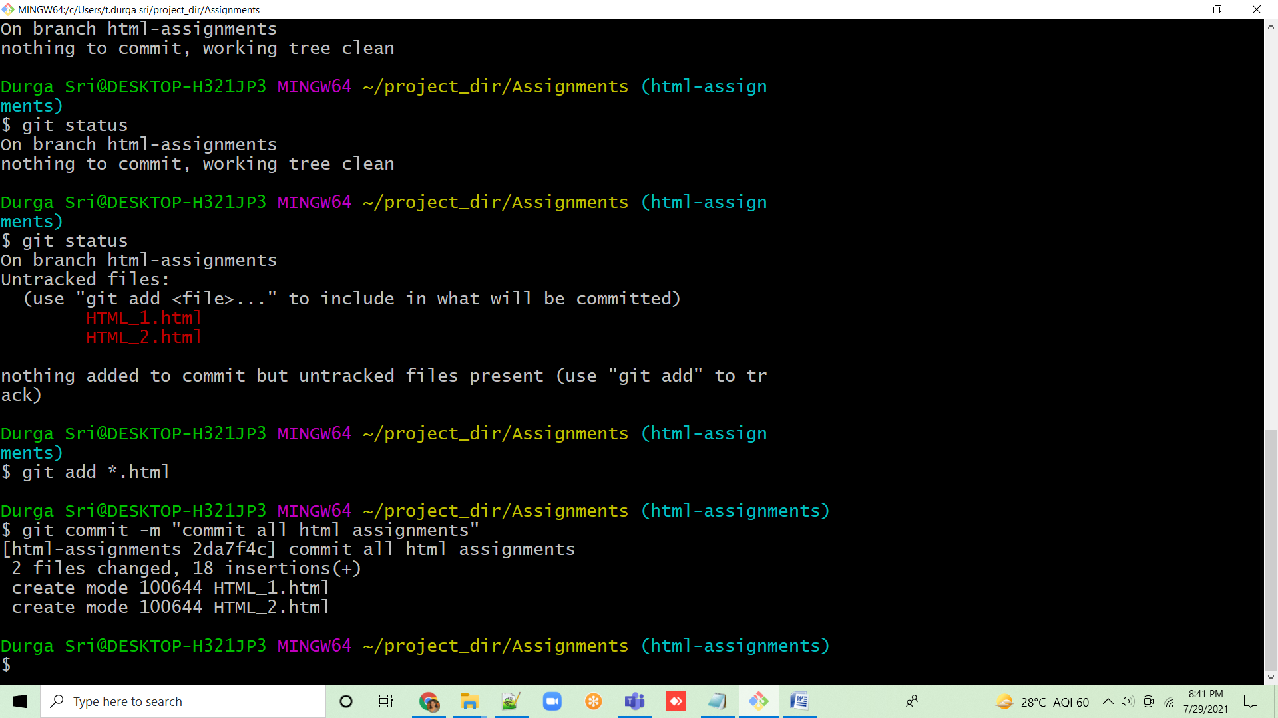

29. Make minor changes into few files belonging to ‘html-assignments’ branch.

30. Commit those changed files

31. Switch to master branch.

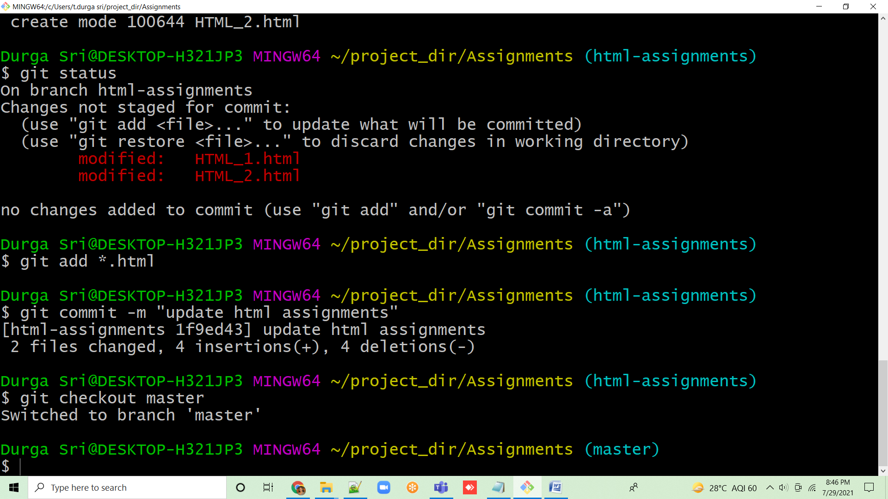

32. Make minor changes into README.txt file & commit those changes into master

33. Again switch to ‘html-assignments’ branch

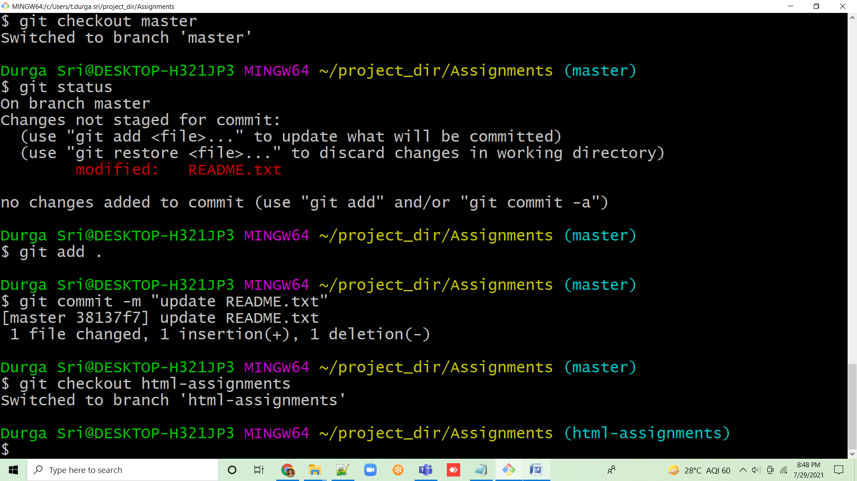

34. Make minor changes into few files belonging to ‘html-assignments’ branch

35. Commit those changes

36. Switch to master

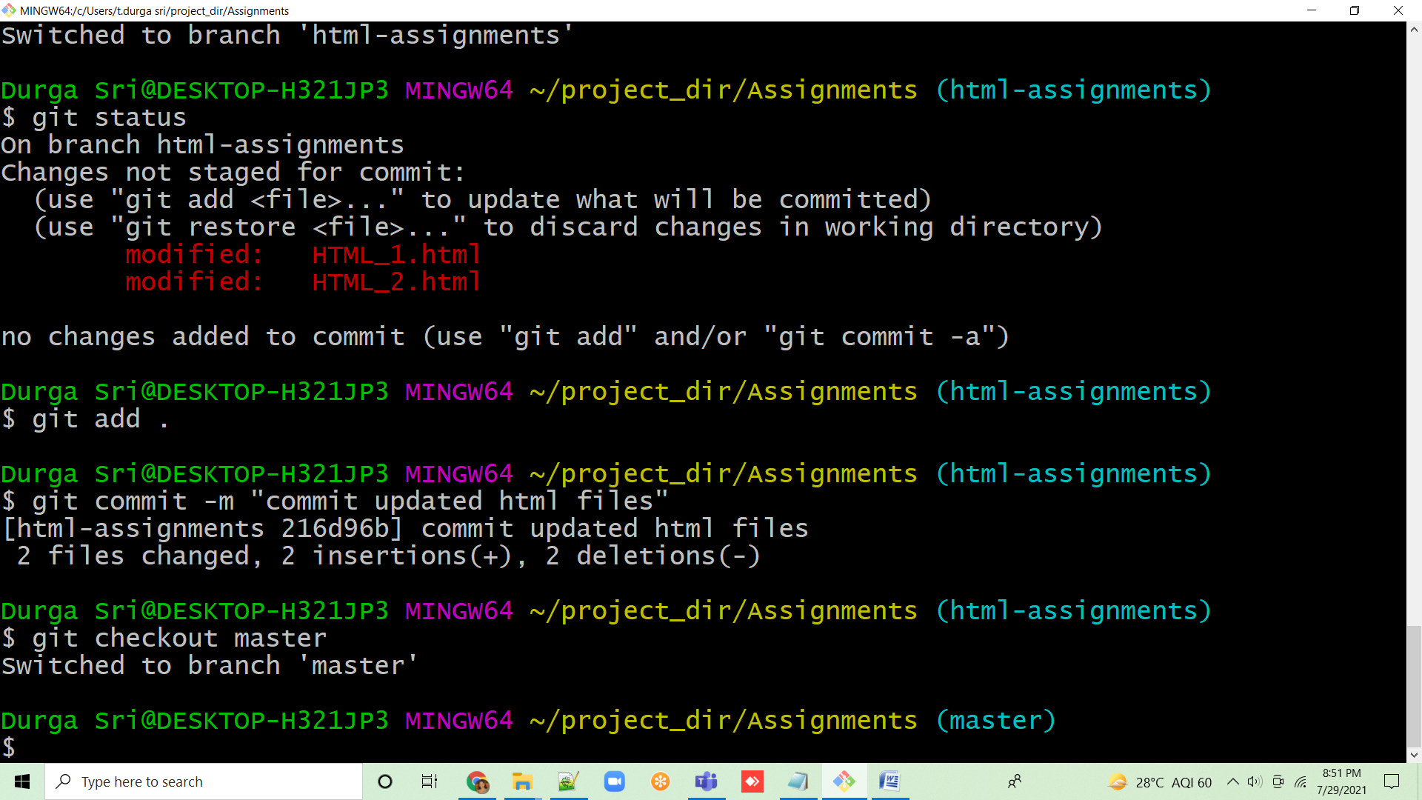

37. Merge ‘html-assignments’ branch into master. Confirm all html assignments are shown in master

38. Finally delete the ‘html-assignments’ branch

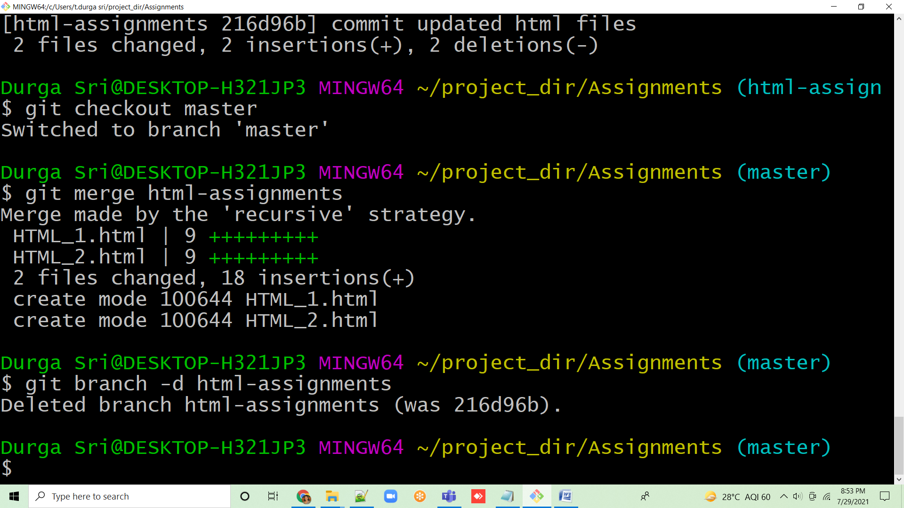

**Section 2:**

1.Create a new branch ‘css-assignments’

2. Switch to ‘css-assignments’ branch

3. Copy all CSS assignments inside ‘Assignments’ folder

4. Commit CSS assignments into ‘css-assignments’ branch

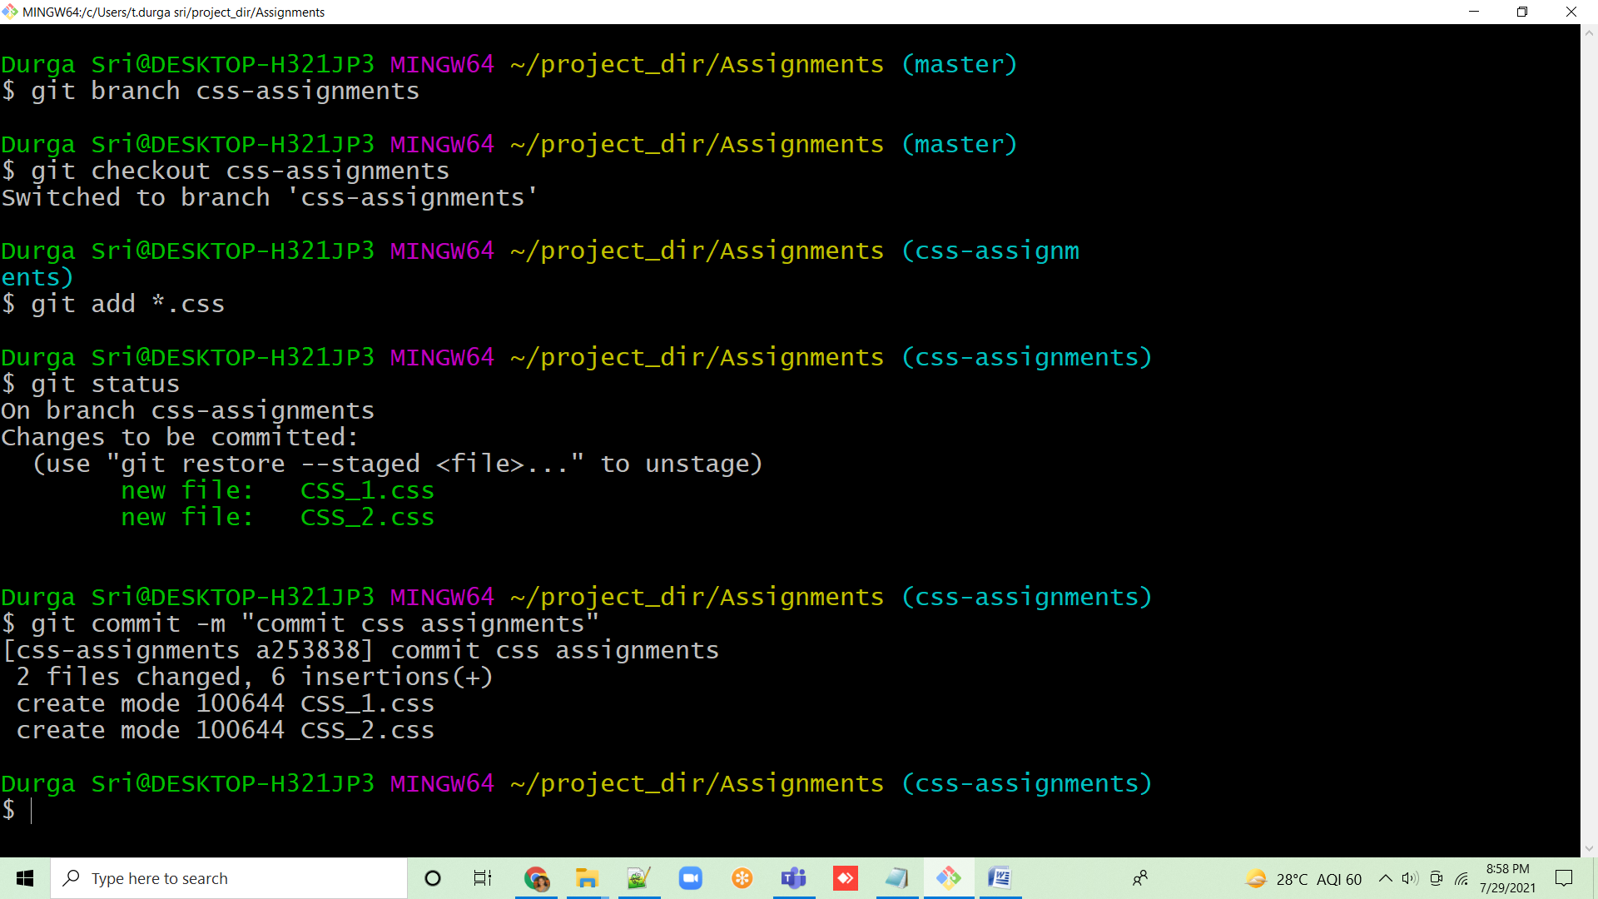

5. Make minor changes into README.txt file on line 1 belonging to ‘css-assignments’ branch

6. Commit those changed files

7. Switch to master branch

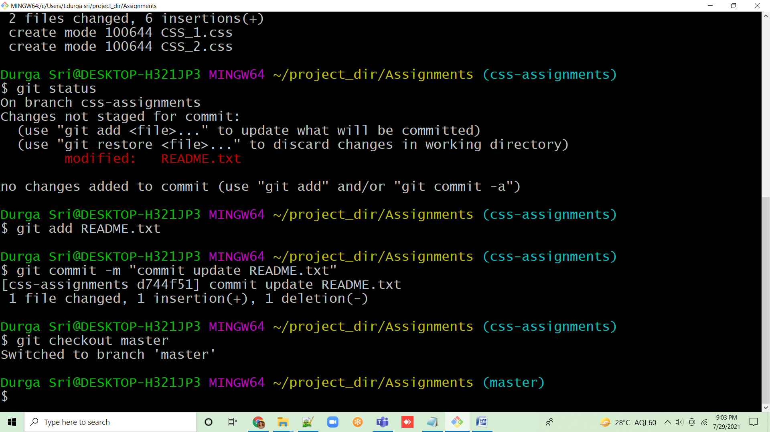

8. Make minor changes into README.txt on line 3 & commit those changes into master.

9. Again switch to ‘css-assignments’ branch

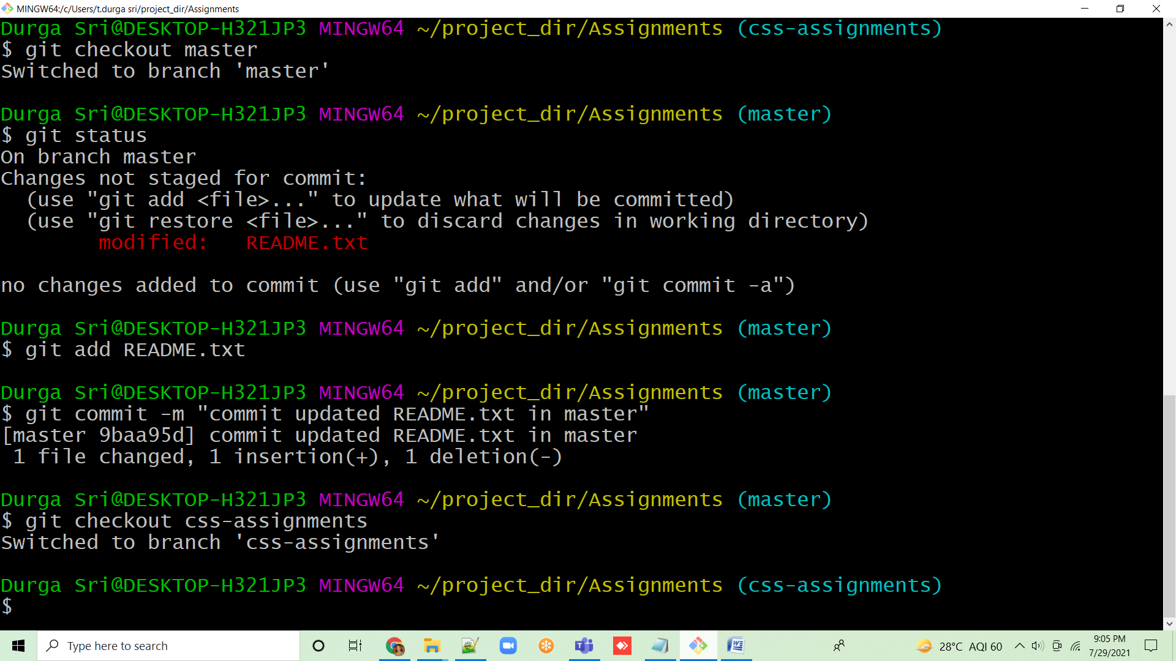

10. Make minor changes into few files belonging to ‘css-assignments’ branch

11. Commit those changes

12. Switch to master.

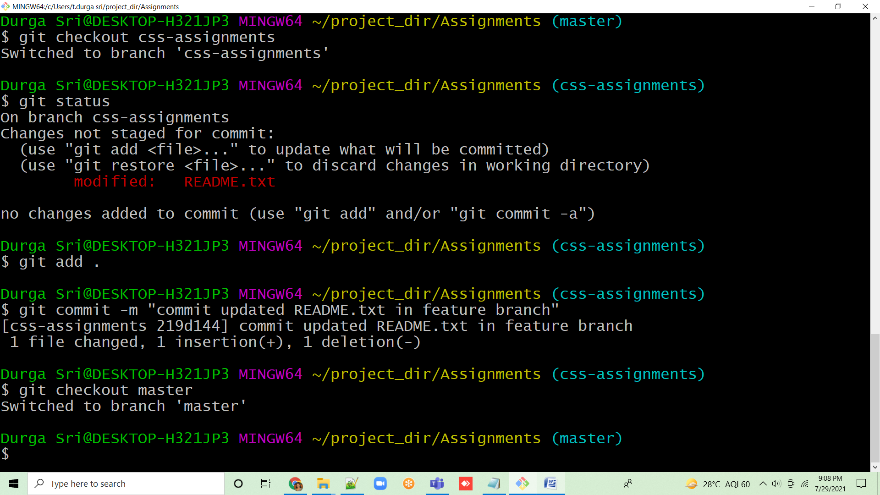

13. Merge ‘css-assignments’ branch into master. Confirm all css assignments are shown in master.

14. Finally delete the ‘css-assignments’ branch.

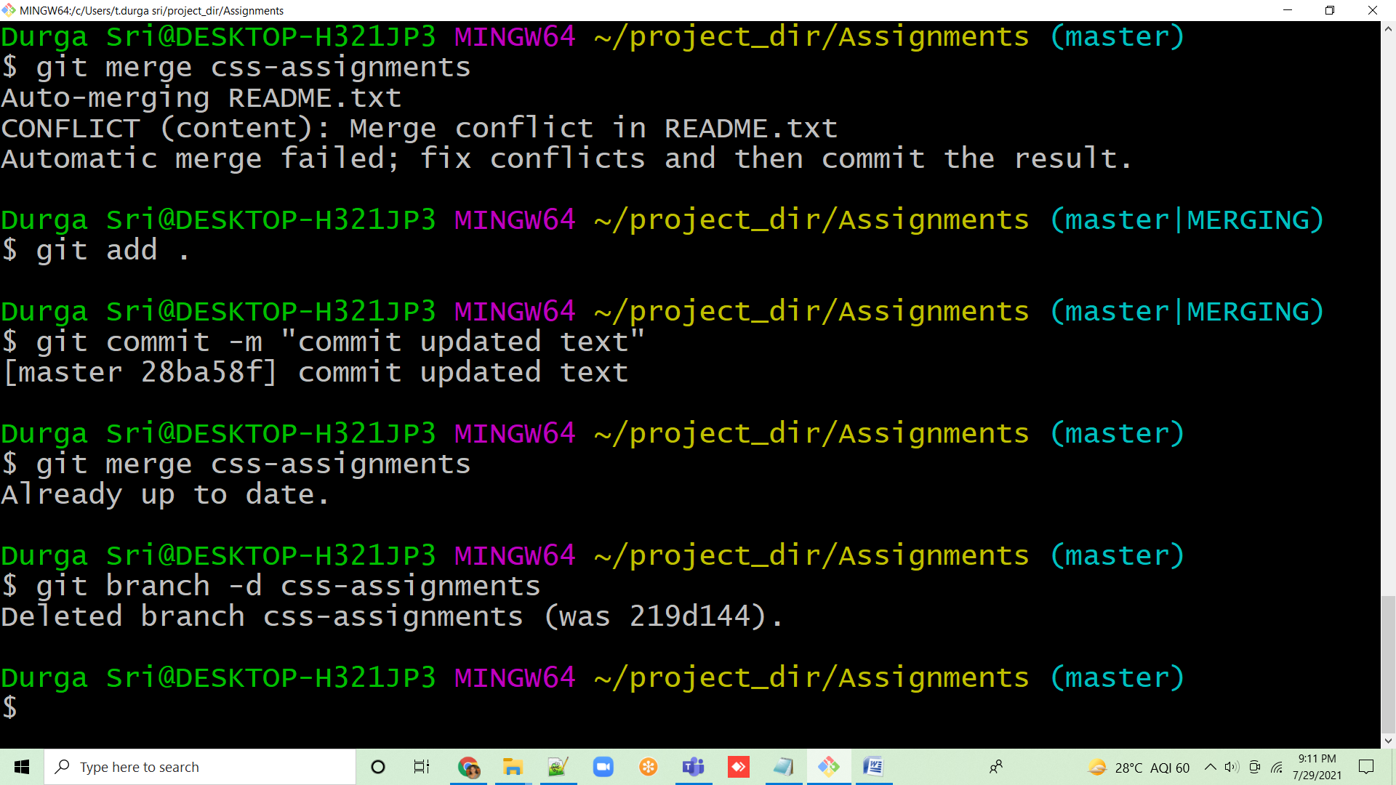

**Section 3:**

1.Create a new branch ‘js-assignments’.

2. Switch to ‘js-assignments’ branch.

3. Copy all JavaScript assignments inside ‘Assignments’ folder.

4. Commit JavaScript assignments into ‘js-assignments’ branch.

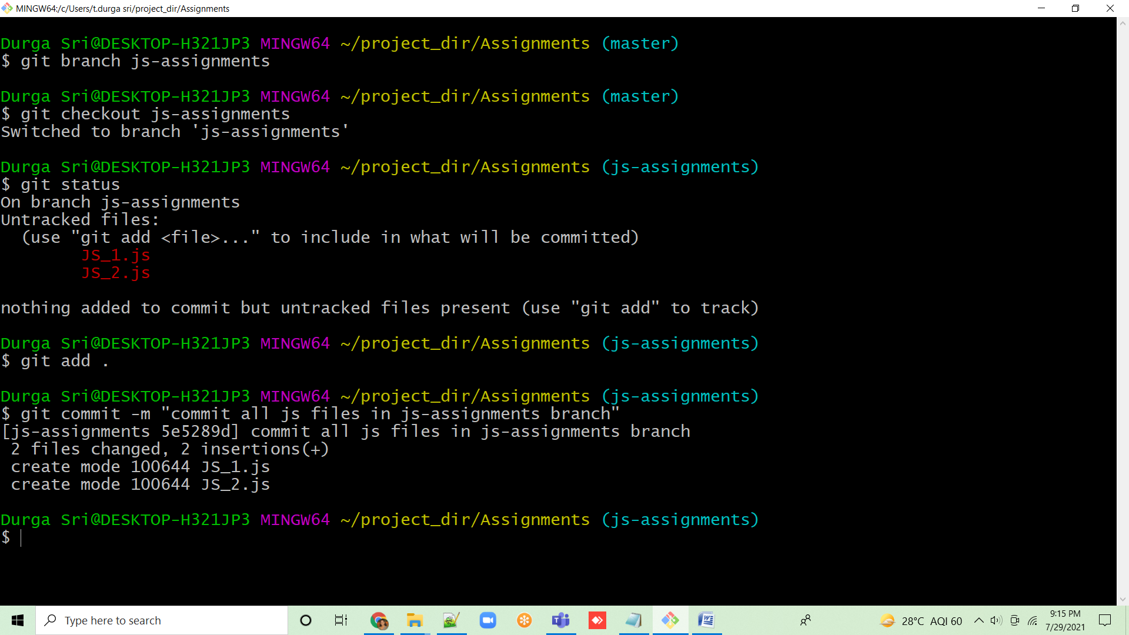

5. Make minor changes into README.txt file on line 1 belonging to ‘js-assignments’ branch.

6. Commit those changed files.

7. Switch to master branch.

8. Make minor changes into README.txt file on line 1 & commit those changes into master.

9. Again switch to ‘js-assignments’ branch.

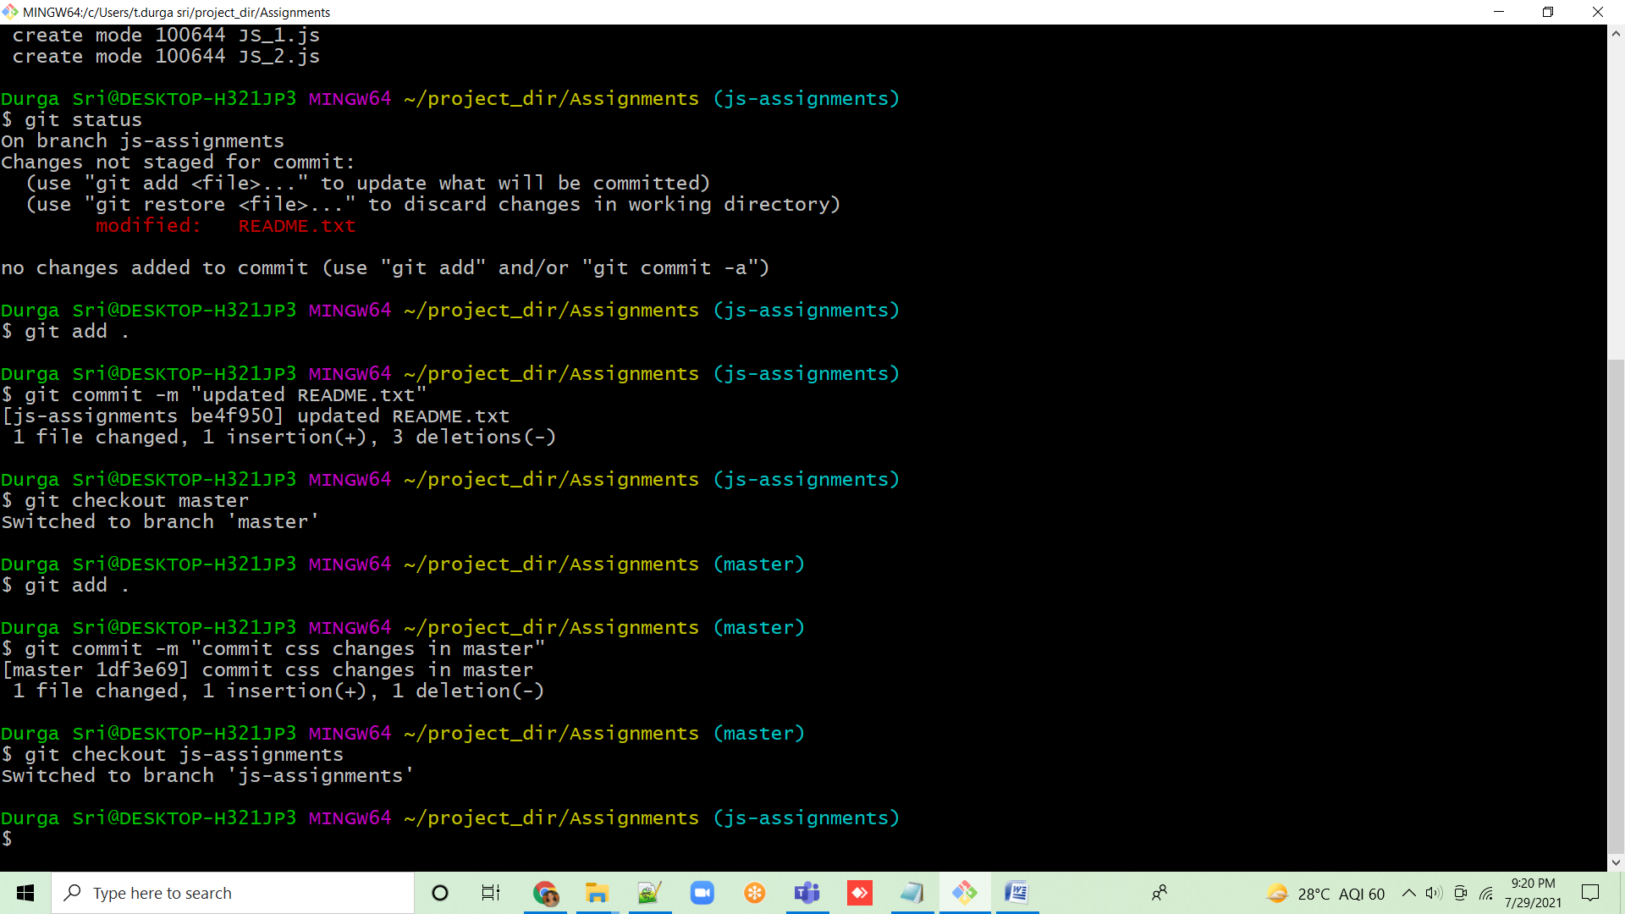

10. Make minor changes into few files belonging to ‘js-assignments’ branch.

11. Commit those changes.

12. Switch to master.

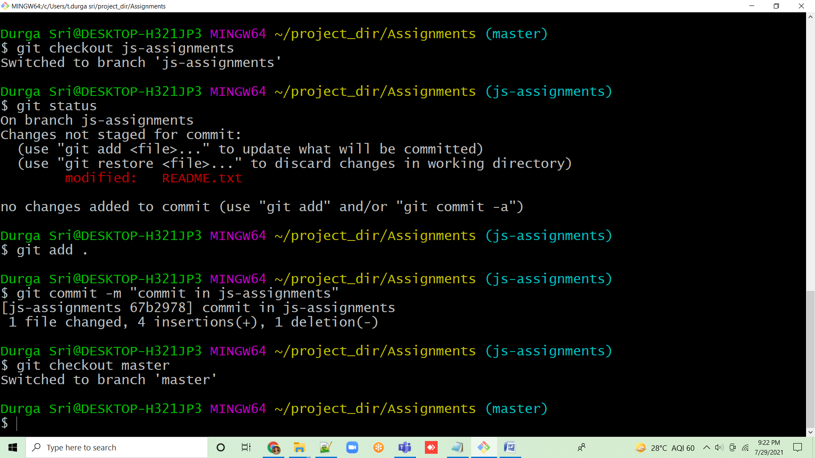

13. Merge ‘js-assignments’ branch into master. Confirm all JavaScript assignments are shown in master.

14. Finally delete the ‘js-assignments’ branch.

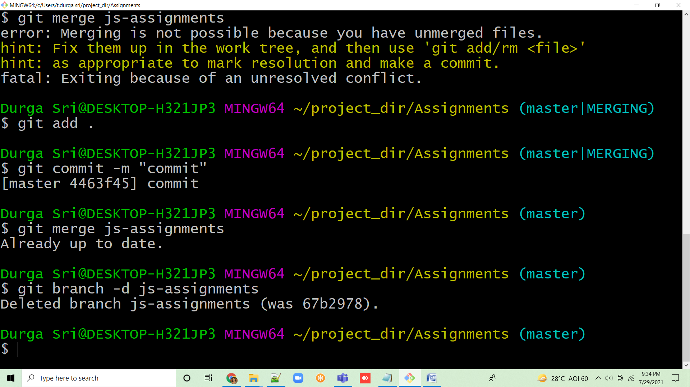

**Section 3(Pushing assignments to remote repository):**

39. Create a github account if you do not have already.

40. Login on into github account.

41. Create new public repository ‘freshersbatch-oct16’.

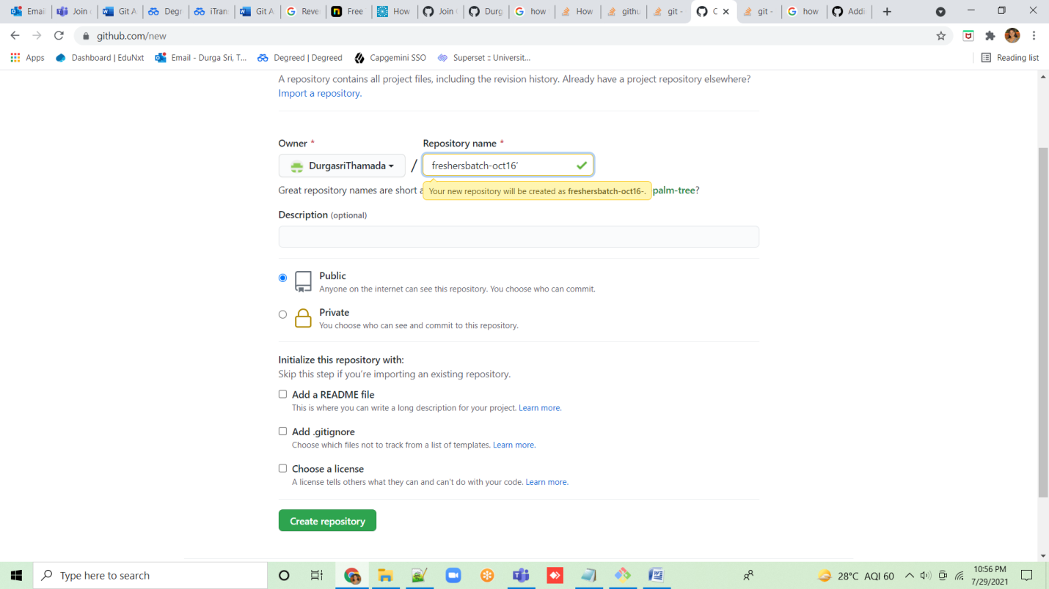

42. Commit & push any sample file to this repository under ‘Assignments’ directory.

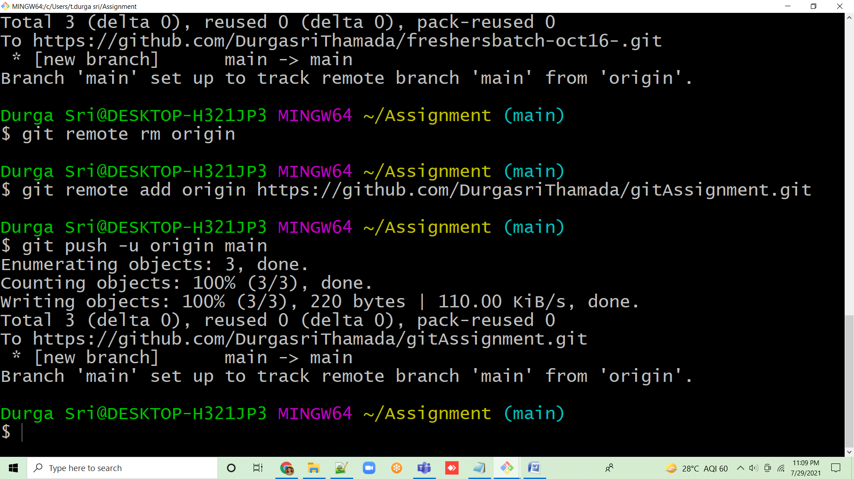

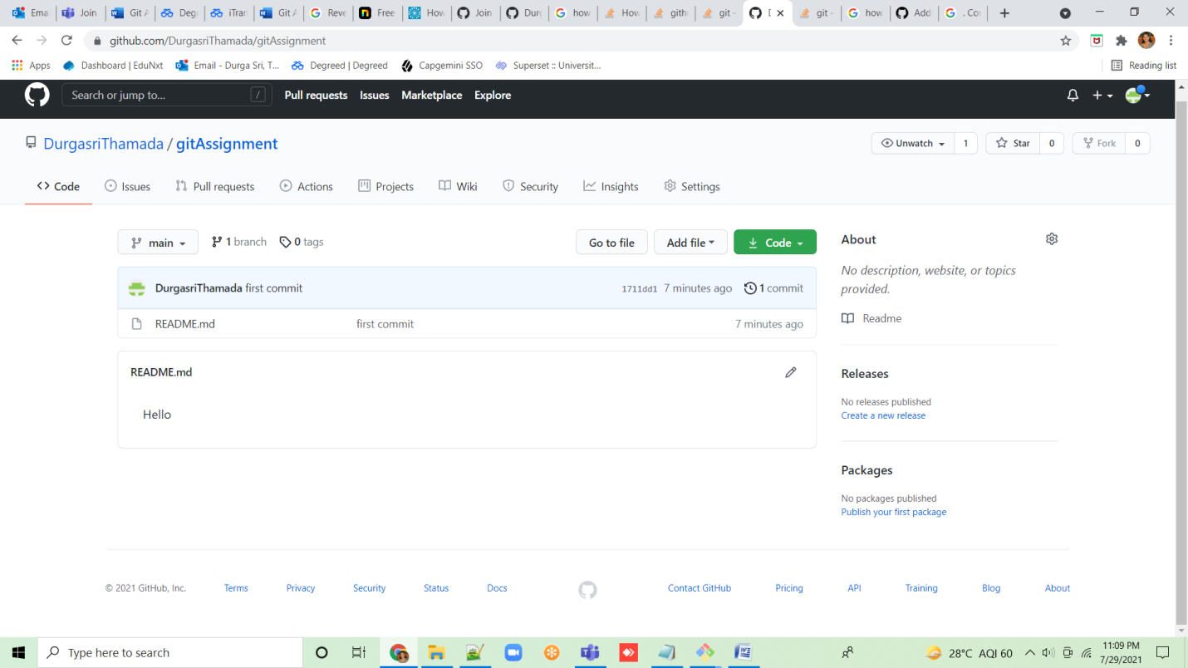

**Section 4:**

1.One developer from project team will create eclipse projects ‘SampleProj’ & add sample source code files. Then commit all files through eclipse GIT plugin.

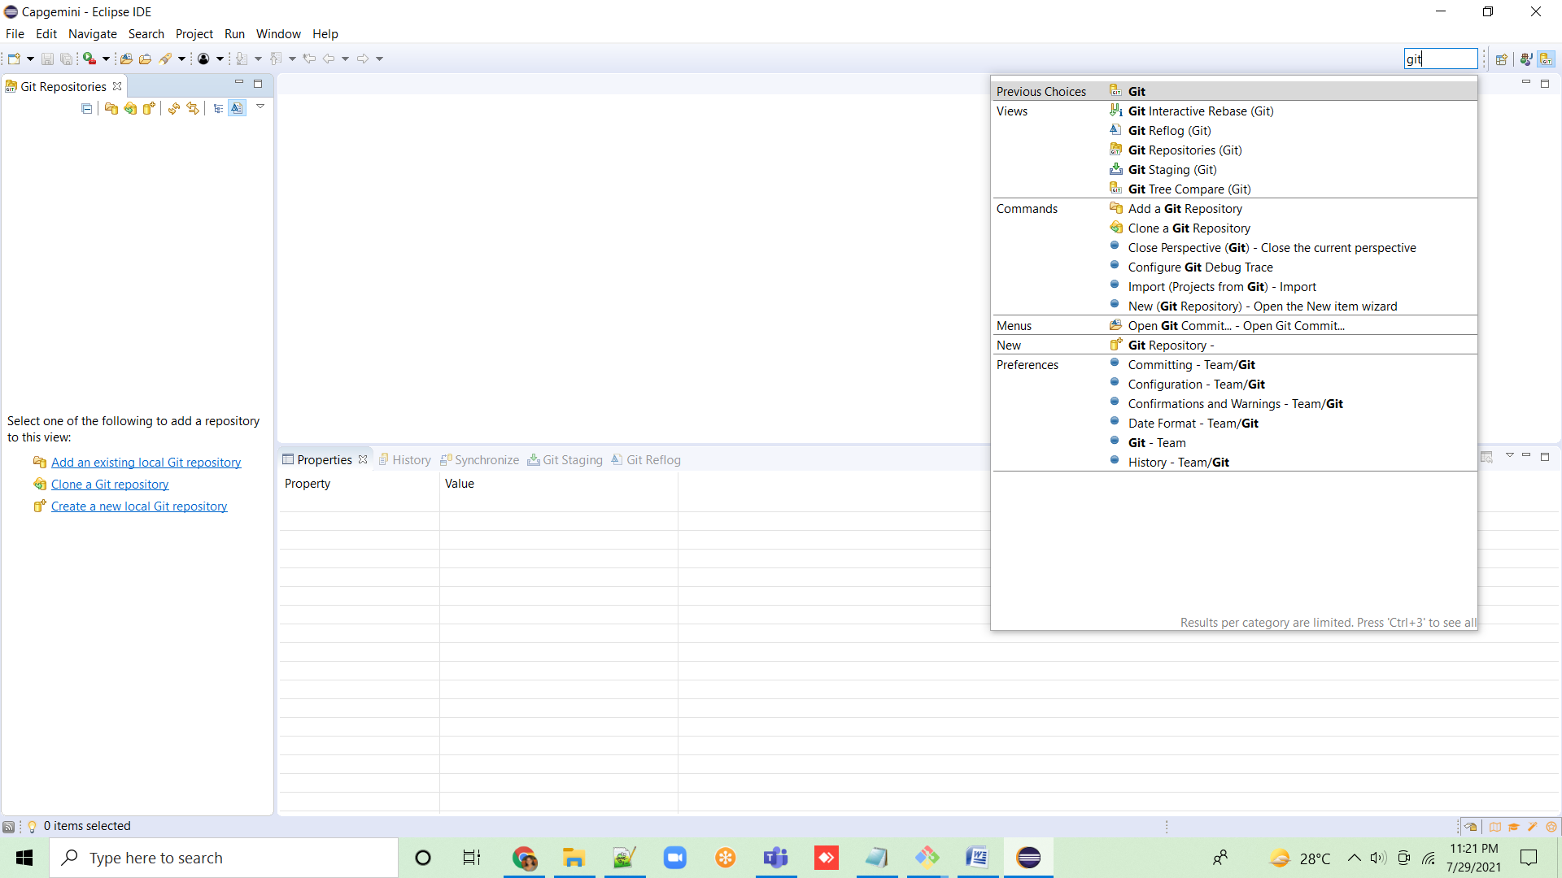

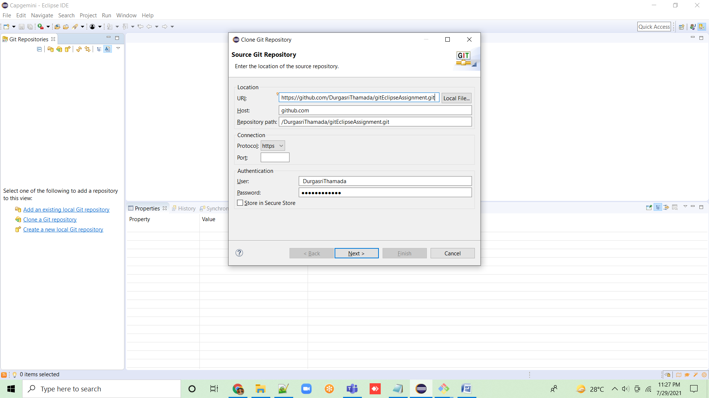

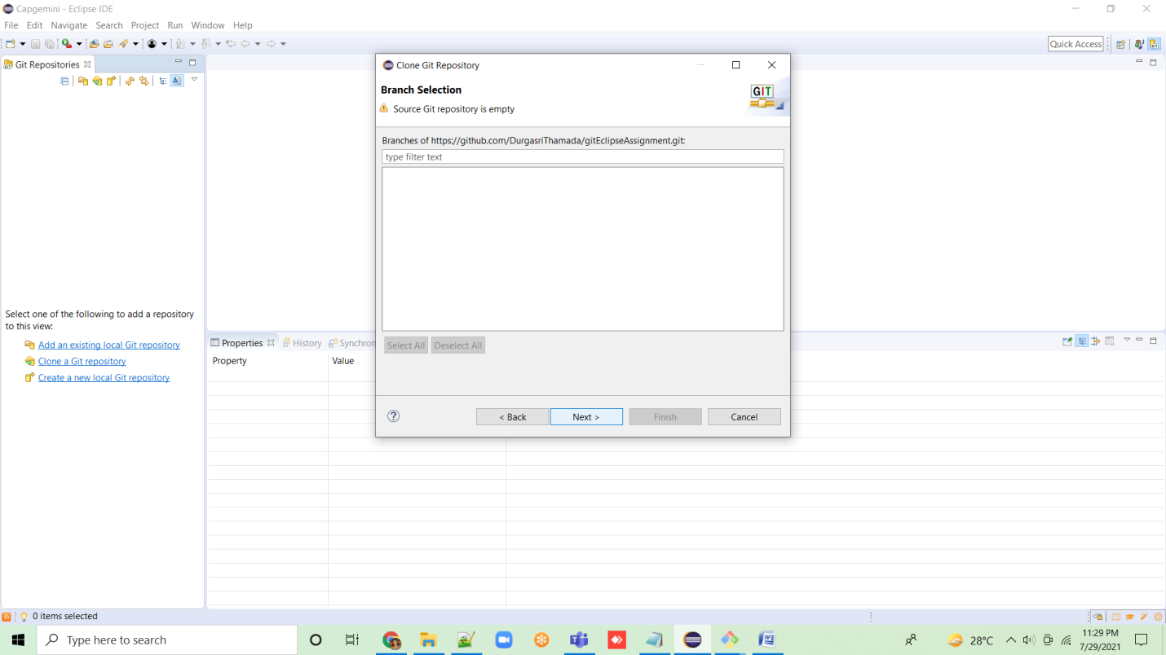

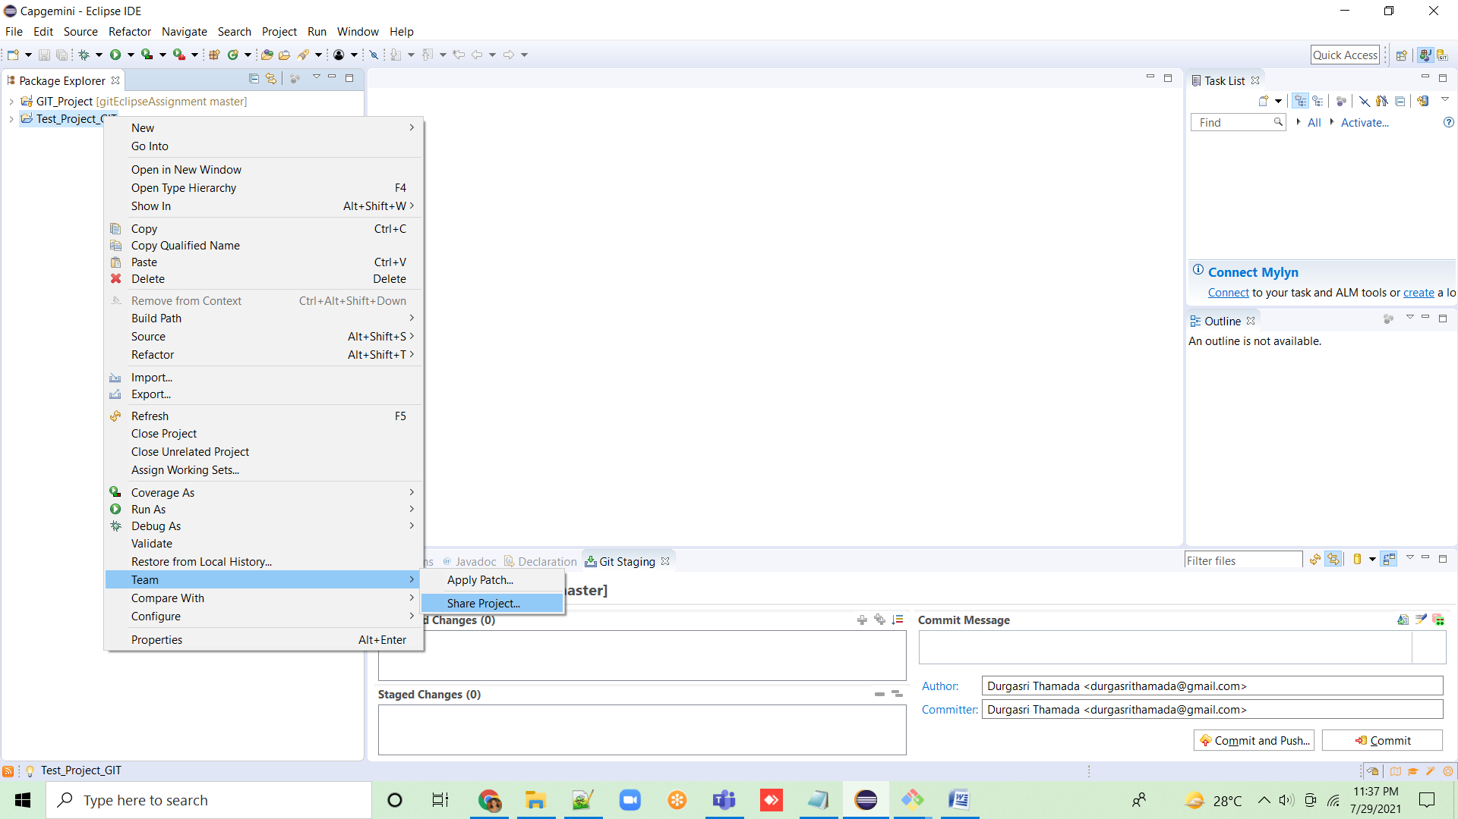

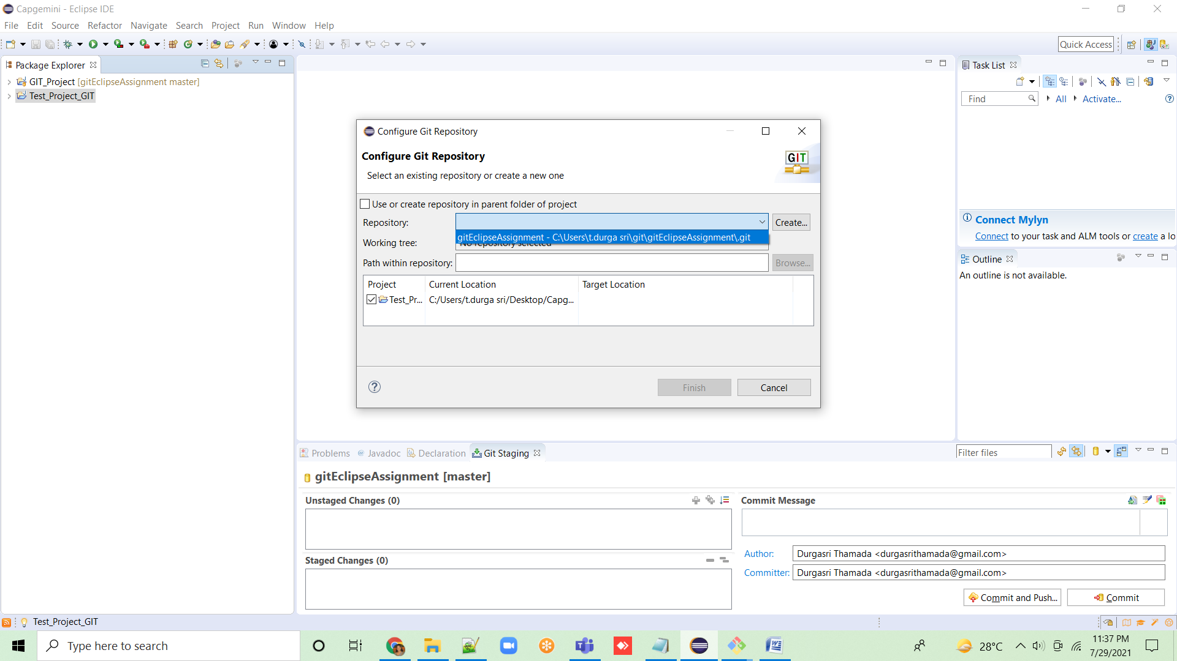

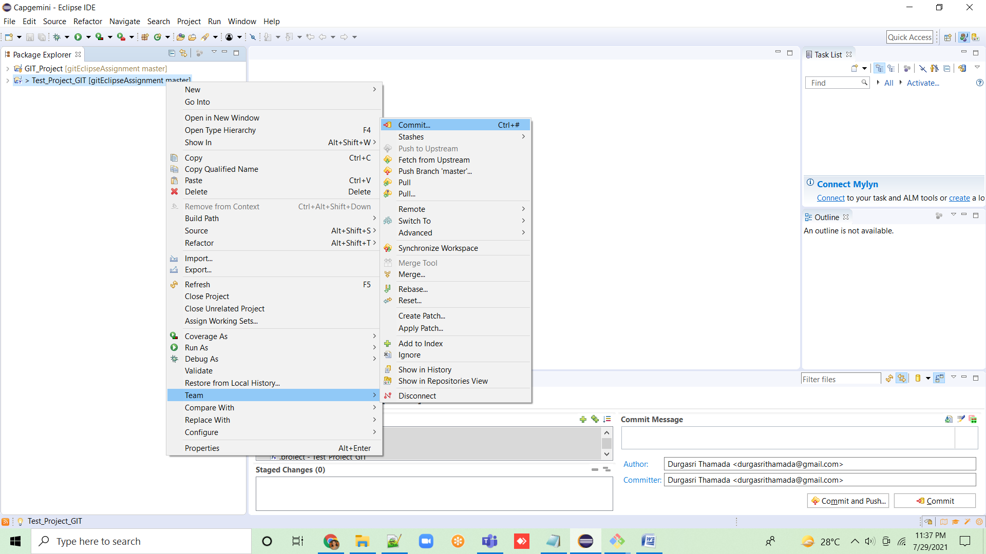

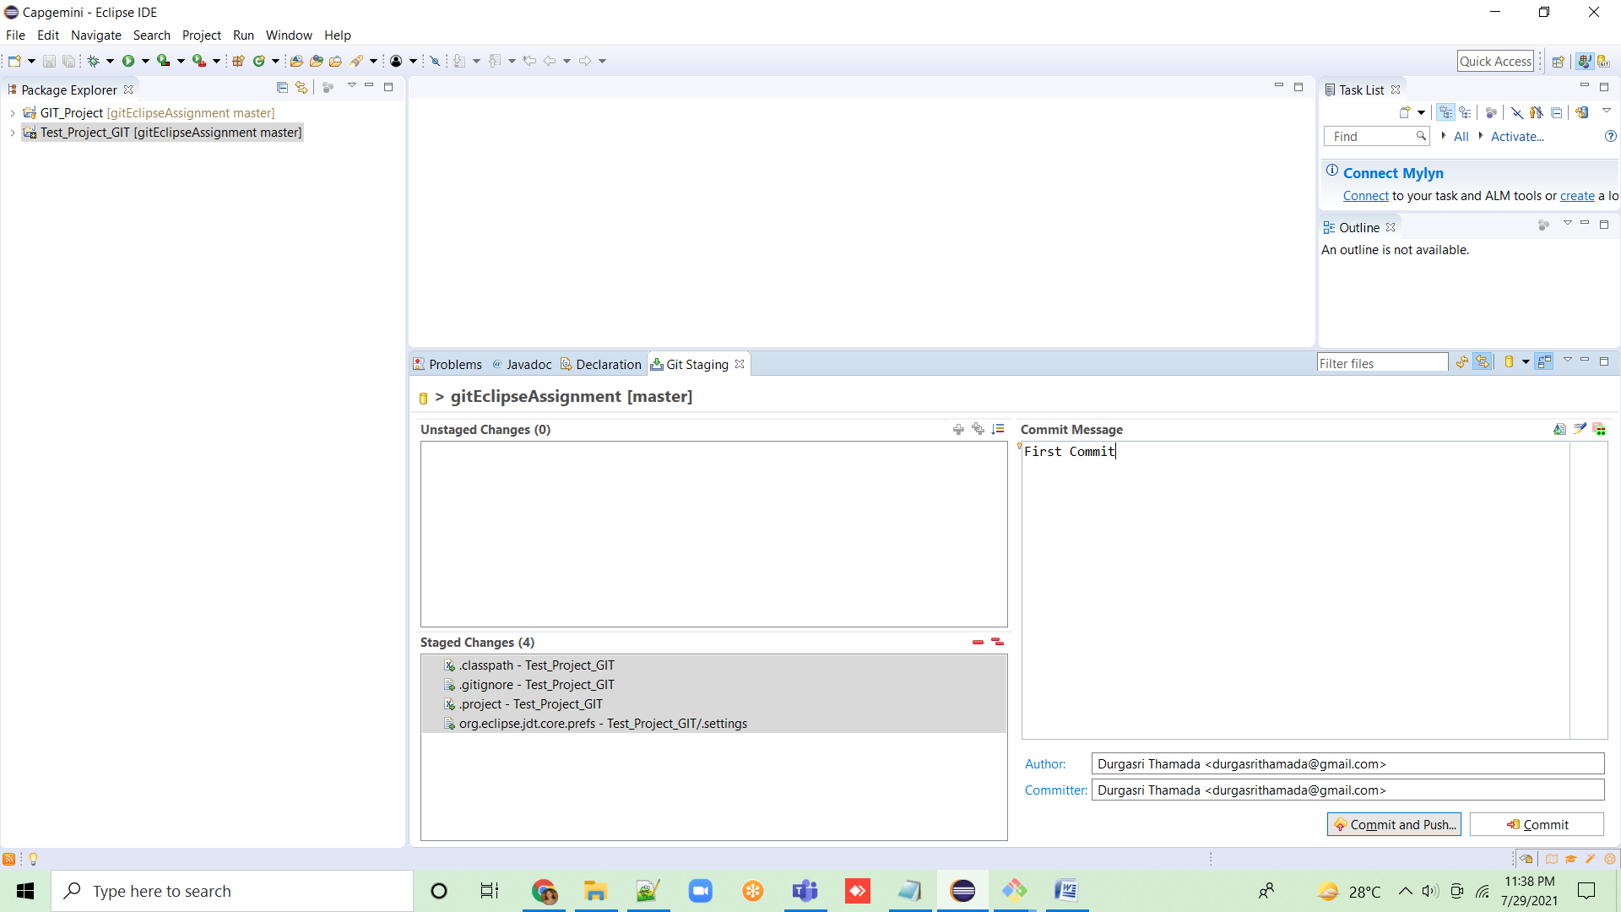

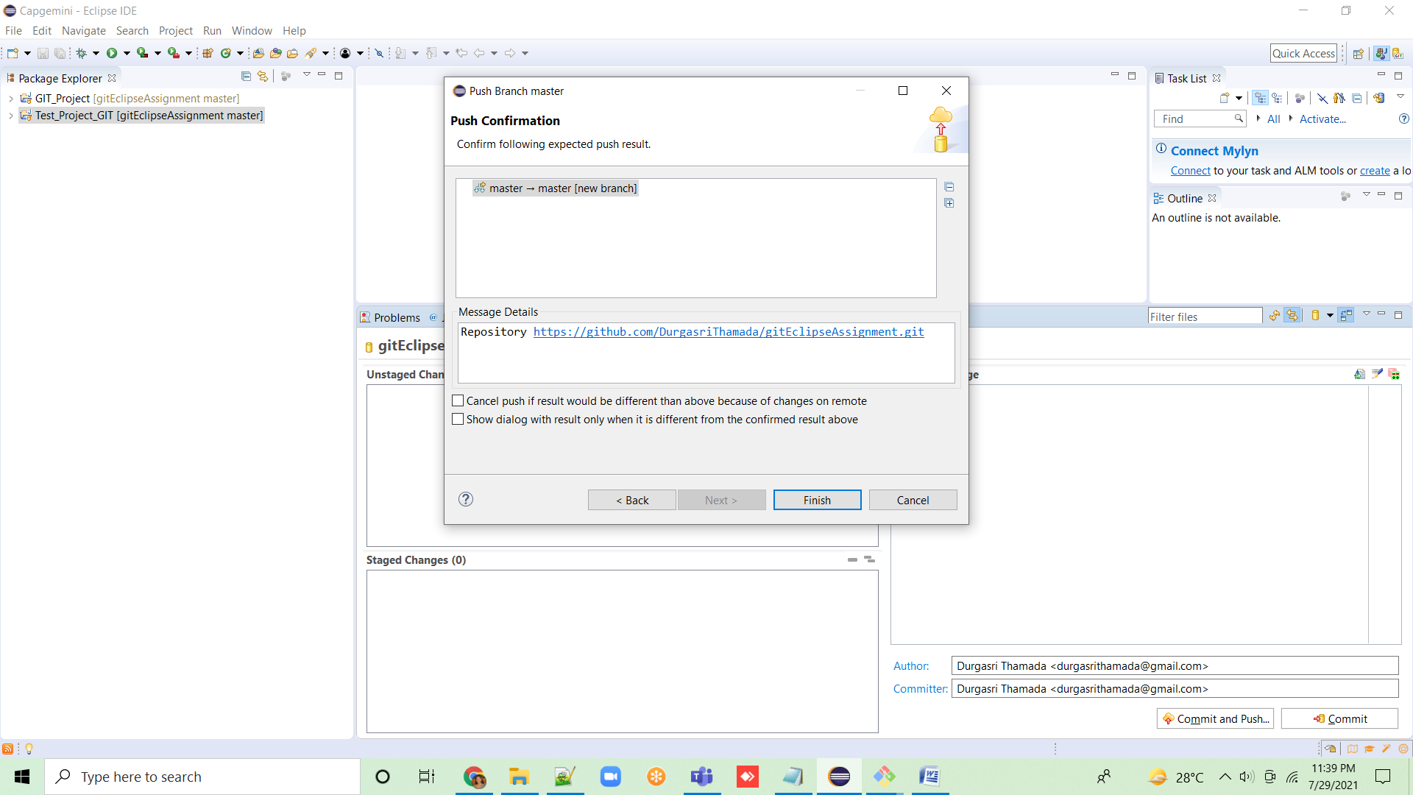

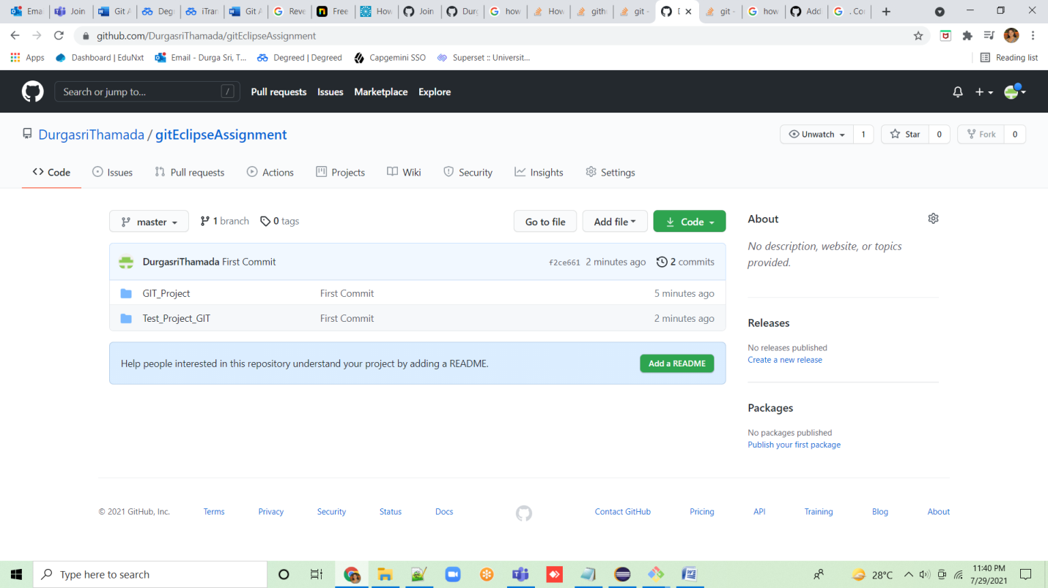

2. Collaborate other team members with your github account so that they can also modify the committed files.

3. Others developers from same team will checkout all files from remote repository. This might get conflicts since certain files fail to merge. In such case, merge it manually.

4. Commit & push the ‘SampleProj’ project.